

69x37 mm 60 50 40

EAN Booklet

Logistic Data

Technical Data

EAN Display

EAN Carton



SMOKING BROWN REGULAR

34-53912

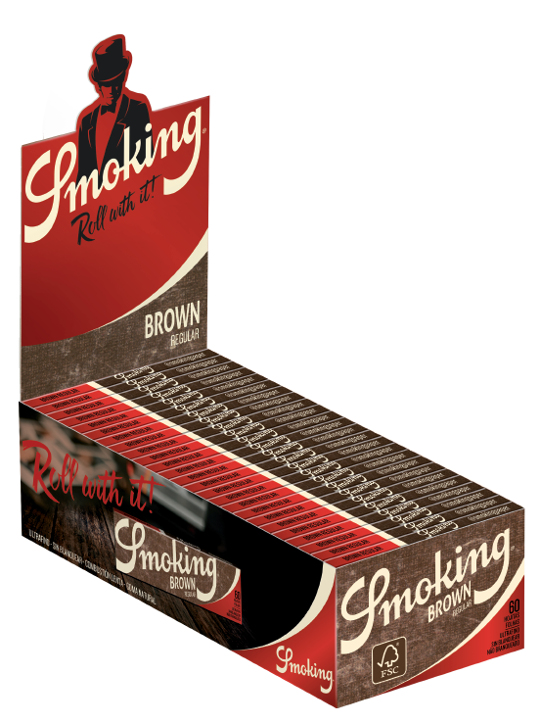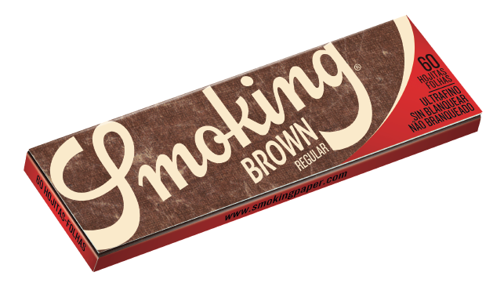

C041521

Unbleached Chlorine Free Ultrathin Paper

≈ 13 g/m2

Slow Burning

FSC® Paper

100% Natural Gum Smoking Watermark

Features