PACKING LIST
DESCRIPTION | REFª | QTY | PHOTO
HOOKAH 40CM TRESOR | 1004304433 | 6 | 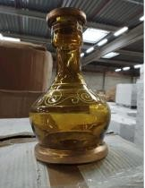
BOWL SADAH CLAY MALE TRESOR | 1004304440 | 3477 | 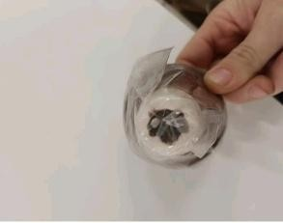
BOWL SADAH LARGE FEMALE TRESOR | 1004304444 | 100 | 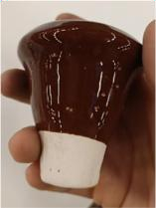
CLASSIC RESERVOIR GASKETS TRESOR | 1004304466 | 360 | 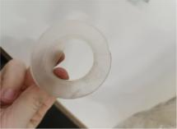
HOOKAH 40CM TRESOR | 1004304433 | 40 | 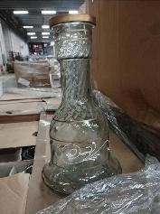
INDIVIDUAL METAL MOUTHPIECE X100 TRESOR | 1004304463 | 200 | 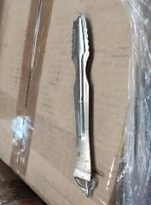
INDIVIDUAL WOOD MOUTHPIECE X100 TRESOR | 1004304465 | 200 | 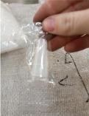

DESCRIPTION | REFª | QTY | PHOTO
HOOKAH TOBACCO CUP 50CM TRESOR | 1004304428 | 15 | 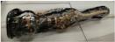
HOOKAH 78CM TRESOR | 1004304435 | 50 | 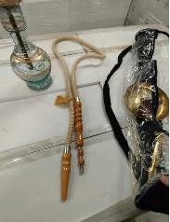
HOOKAH 80CM TRESOR | 1004304436 | 650 | 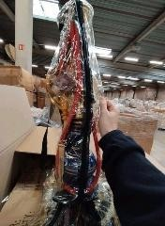
CHARCOAL TONGS COPPER TRESOR | 1004304458 | 1444 | 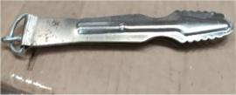
CHARCOAL TRAY COPPER TRESOR | 1004304461 | 110
HOOKAH 80CM TRESOR | 1004304436 | 7
RESERVOIR 1 OUTLET DIAM 26CM TRESOR | 1004304457 | 96
RESERVOIR 1 OUTLET DIAM 26CM TRESOR | 1004304457 | 492

DESCRIPTION | REFª | QTY | PHOTO
HOOKAH 2 OUTLETS 75CM TRESOR | 1004304431 | 310 | 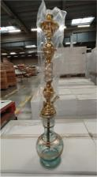
BOWL SADAH CLAY XL TRESOR | 1004304438 | 96 | 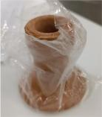
RESERVOIR 4 OUTLETS DIAM 30CM TRESOR | 1004304456 | 150
INDIVIDUAL METAL MOUTHPIECE X100 TRESOR | 1004304463 | 500
INDIVIDUAL WOOD MOUTHPIECE X100 TRESOR | 1004304465 | 400
RESERVOIR GROBOURI DIAM 26CM TRESOR | 1004304454 | 1030
HOOKAH 2 OUTLETS 65CM TRESOR | 1004304430 | 54 | 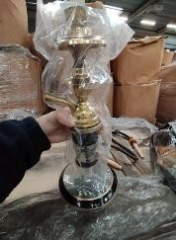
HOOKAH 2 COLLARS 65CM TRESOR | 1004304429 | 90 | 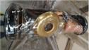

DESCRIPTION | REFª | QTY | PHOTO
DISPOSABLE FLEXIBLE HOSE 150CM X200 TRESOR | 1004304453 | 12620 | 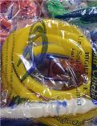
RESERVOIR 2 OUTLETS DIAM 30CM TRESOR | 1004304455 | 216
DISPOSABLE FLEXIBLE HOSE 140CM X250 TRESOR | 1004304452 | 1440 | 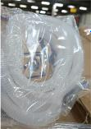
HOOKAH 78CM TRESOR | 1004304435 | 72
HOOKAH TOBACCO CUP 50CM TRESOR | 1004304428 | 20
HOOKAH 2 OUTLETS 65CM TRESOR | 1004304430 | 10
HOOKAH 2 OUTLETS 75CM TRESOR | 1004304431 | 34
BOWL SADAH CLAY XL TRESOR | 1004304438 | 16

DESCRIPTION | REFª | QTY | PHOTO
DISPOSABLE FLEXIBLE HOSE 140CM X250 TRESOR | 1004304452 | 21
RESERVOIR 1 OUTLET DIAM 26CM TRESOR | 1004304457 | 15
CHARCOAL TONGS COPPER TRESOR | 1004304458 | 1244 | 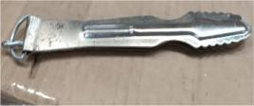
HOOKAH FILTER X12 TRESOR | 1004304467 | 240 | 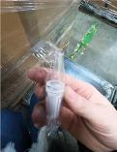
HOOKAH 55CM STAINLESS TRESOR | 1004304434 | 108 | 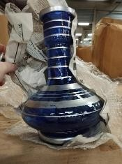
HOOKAH TABEH COPPER 75CM TRESOR | 1004304437 | 64
HOOKAH TOBACCO CUP 50CM TRESOR | 1004304428 | 180
HOOKAH 2 OUTLETS 75CM TRESOR | 1004304431 | 64

DESCRIPTION | REFª | QTY | PHOTO
HOOKAH 35CM TRESOR | 1004304432 | 20 | 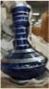
26261

